**How to install and run the project on windows**

**Navigate to the project location**

Navigate to the project location in the command prompt or terminal for example if its located in the desktop, type the following

*Cd desktop*

Then *cd products*

or

C:\Users\ADMIN> *cd desktop/products*

***2* Set up the virtual environment**

Write the following command to activate virtual environment to avoid installing packages globally

*Python –m venv env*

**3 activate vitual environment**

*Env\scripts\activate*

**4 install the dependencies**

*Pip install –r requiremets.txt*

**5 run the migrations to the database**

*Py manage.py makemigrations*

**7 the migrate**

*Py manage.py migrate*

**8 run the project locally**

*Python manage.py runserver*

The development server will be started at port *http://127.0.0.1:8000/*

Copy <http://127.0.0.1:8000/> to the browser

***9 admin page for adding contents***

[*http://127.0.0.1:8000/admin*](http://127.0.0.1:8000/admin)

username – admin

password -1234

**homepage**

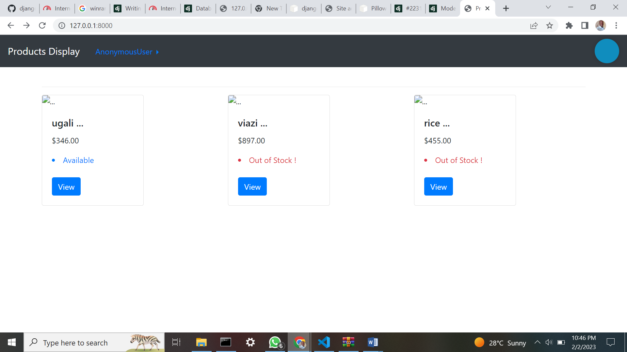

Login page

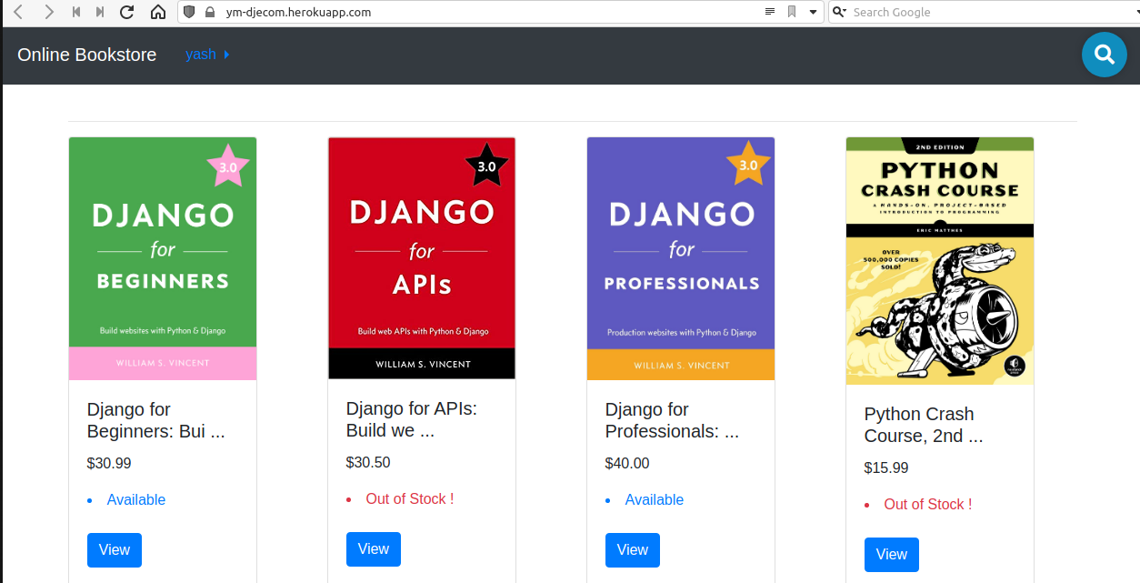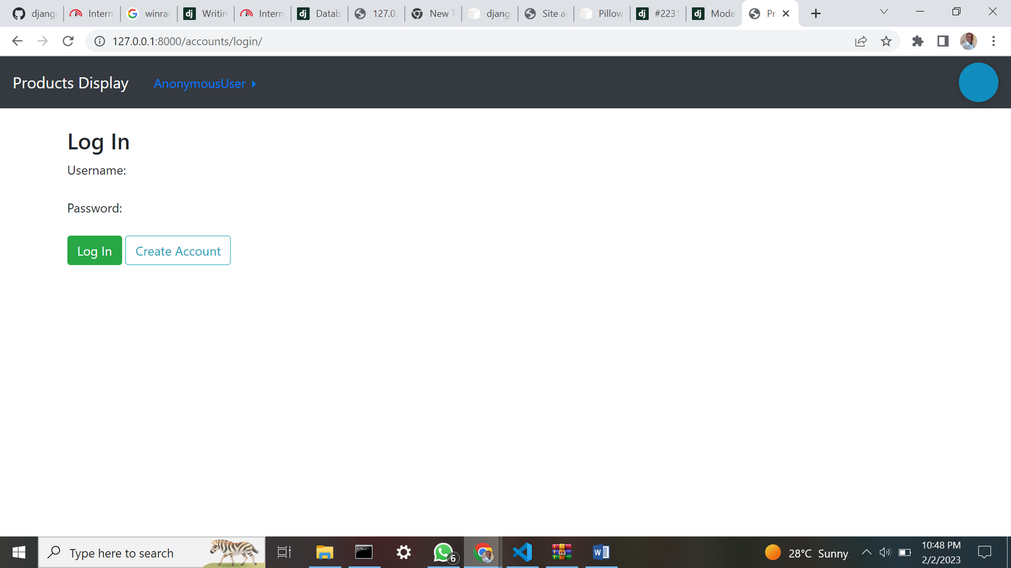

**Signup page**

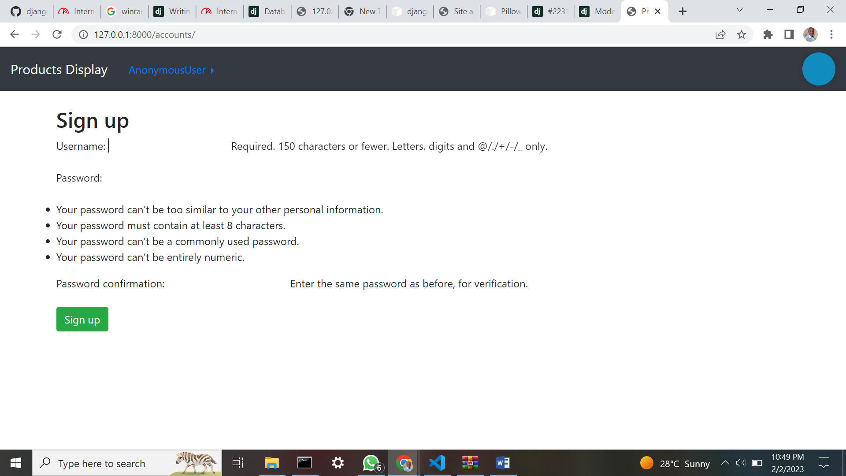

**Product Detail Page**

**Checkout Page**

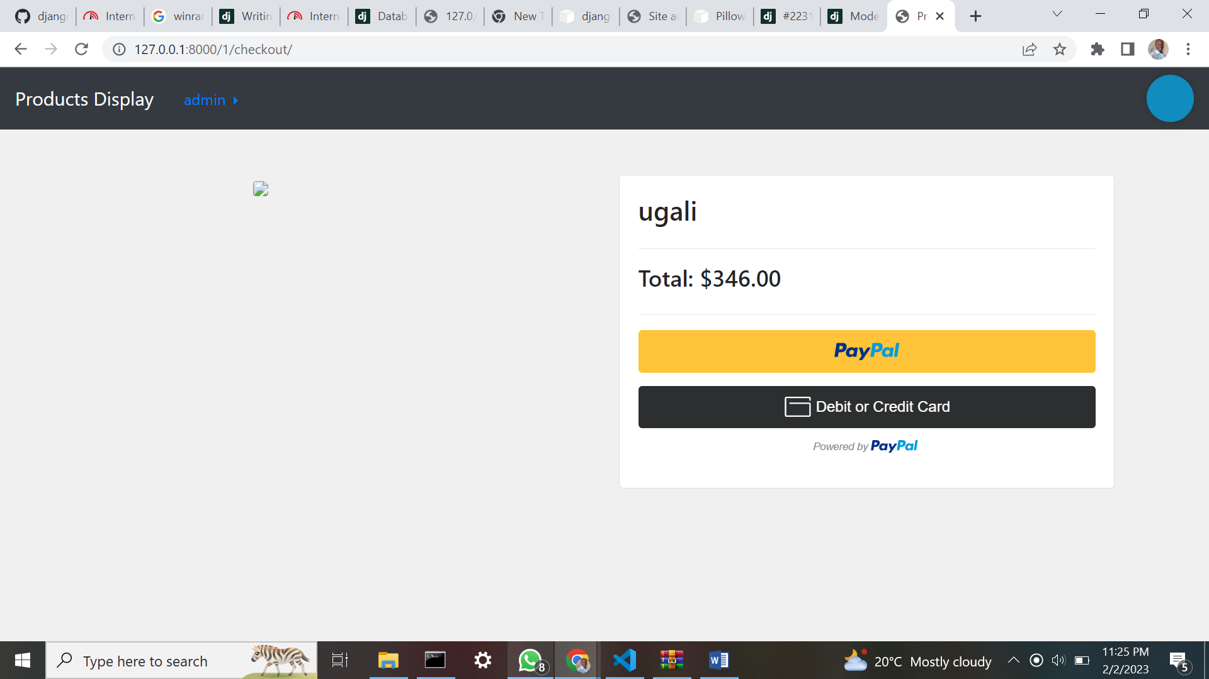

**Admin page**

